**­­­­­­­­­­­­­FRONT END ENGINEERING-II**

Project Report­­

Semester-IV(Batch-2022)

Currency converter

**Supervised By: Submitted By:**

Mr. Raveesh Samkaria Sidharth Garg

2210990849

Group-G13

**Department of Computer Science and Engineering**

**Chitkara University Institute of Engineering & Technology, Chitkara University, Punjab**

**Table Of Content**

|  |  |  |
| --- | --- | --- |
| **Sr No.** | **Section** | **Page No.** |
| **1.** | Introduction | 4 |
| **2.** | Problem Statement | 5 |
| **3.** | Technical Details | 7 |
| **4.** | File Structure | 8 |
| **5.** | Result | 9 |
| **6.** | References | 22 |

Introduction

Background

"Welcome to our currency converter, a powerful tool designed to simplify your financial transactions across borders. Whether you’re a traveler, business owner, or simply curious about global exchange rates, our converter provides real-time currency conversions with accuracy and convenience. Say goodbye to the hassle of manual calculations and let our tool handle the complexities, ensuring you always have the most up-to-date information at your fingertips. Get ready to navigate the world of currencies effortlessly, saving time and maximizing the value of your money."

Objectives

Certainly! Here are some common objectives of a currency converter:

1. **Convenience**: The primary objective is to provide users with a convenient way to convert currencies quickly and accurately. This convenience can be particularly valuable for travelers, businesses engaged in international trade, investors, and anyone dealing with foreign currencies.

2. **Accuracy**: Another key objective is to ensure the accuracy of currency conversions. Users rely on currency converters to provide precise exchange rates, reflecting the current market conditions. Any discrepancies in the conversion rates could lead to financial losses or miscalculations.

3. **Real-time Updates**: Currency values fluctuate constantly due to various factors such as economic news, geopolitical events, and market sentiment. Therefore, a currency converter should provide real-time updates to reflect these changes accurately. Timely updates ensure that users have access to the most current exchange rates.

4. **User-Friendly Interface**: An objective of a currency converter is to offer a user-friendly interface that is easy to navigate and understand. The tool should be intuitive, allowing users to input currencies and amounts effortlessly and receive conversion results quickly.

5. **Compatibility**: In today's digital age, people access information and tools from various devices and platforms. Thus, a currency converter should be compatible with different devices (such as desktop computers, smartphones, and tablets) and operating systems (such as Windows, iOS, and Android).

6. **Customization**: Some users may have specific preferences or requirements regarding currency conversions. Therefore, offering customization options such as selecting favorite currencies, setting conversion preferences, or saving conversion history can enhance the user experience.

7. **Reliability and Security**: Users need assurance that the currency converter is reliable and secure. This includes ensuring that the tool is free from errors or bugs that could affect conversion accuracy and implementing security measures to protect users' data and transactions.

8. **Educational Resources**: Providing additional educational resources such as currency news, exchange rate trends, and currency conversion tips can help users better understand the dynamics of foreign exchange markets and make informed decisions.

By focusing on these objectives, a currency converter can effectively meet the needs of its users and provide them with a valuable tool for managing currency-related tasks.

Significance

1. **Facilitating International Trade**: Currency converters enable businesses to conduct transactions across borders by providing a means to convert between different currencies. This facilitates international trade and commerce by simplifying the process of buying and selling goods and services in foreign markets.
2. **Supporting Travel and Tourism**: For travelers, currency converters are indispensable tools for managing finances while abroad. They help travelers understand the value of their home currency in the destination country, allowing for effective budgeting and spending decisions during travel and tourism activities.
3. **Enabling Investment Diversification**: Investors use currency converters to assess the performance of their investments denominated in foreign currencies. They also rely on currency conversion to diversify their investment portfolios by gaining exposure to different currencies and markets, thereby reducing overall investment risk.
4. **Managing Foreign Exchange Risk**: Businesses and individuals use currency converters to manage foreign exchange risk associated with currency fluctuations. By converting between currencies at opportune moments, they can mitigate the impact of adverse exchange rate movements on financial transactions and investments.
5. **Promoting Economic Integration**: Currency converters play a crucial role in promoting economic integration by facilitating cross-border transactions and investments. They contribute to the interconnectedness of global financial markets, fostering economic cooperation and collaboration among nations.
6. **Supporting Monetary Policy**: Governments and central banks rely on currency converters to implement monetary policy measures effectively. Exchange rate data provided by currency converters informs policymakers about the relative strength of domestic and foreign currencies, guiding decisions on interest rates, inflation targeting, and foreign exchange interventions.
7. **Empowering Consumers and Businesses**: Currency converters empower consumers and businesses by providing access to real-time exchange rate information and enabling informed decision-making. They help individuals and organizations maximize the value of their money in international transactions and investments.
8. **Promoting Financial Inclusion**: Currency converters contribute to financial inclusion by breaking down barriers to accessing global financial markets. They provide individuals and businesses, particularly those in emerging economies, with the tools and resources needed to participate in international finance and commerce.

.

### Problem Definition

### "The challenge is to develop a currency converter solution that provides accurate and real-time exchange rate information for converting between different currencies. This solution should be user-friendly, reliable, and accessible across multiple platforms and devices. It should cater to the needs of diverse users, including travelers, businesses, investors, and individuals engaging in international transactions. Key considerations include ensuring precision in currency conversions, offering seamless integration with existing financial systems and platforms, providing timely updates on exchange rate fluctuations, and implementing security measures to protect users' data and transactions. Additionally, the solution should strive to enhance user experience through intuitive interface design, customizable features, and supplementary educational resources on currency markets and trends. Ultimately, the goal is to develop a comprehensive currency converter tool that empowers users to make informed decisions and efficiently manage their currency-related tasks in an increasingly globalized world."

#### **Software Requirements**

Frontend Frameworks:

HTML: Markup language for structuring the web pages.

Bootstrap: Frontend framework for responsive and mobile-first design.

JavaScript: Programming language for adding interactivity and dynamic features to the application.

JavaScript library for simplifying DOM manipulation and event handling

#### **Hardware Requirements**

Since the age calculator project primarily involves frontend web development, the hardware requirements are minimal:

1. Development Machine:

• Personal computer or laptop with sufficient processing power and memory for web development tasks.

• Operating System: Windows, macOS, or Linux.

2. Internet Connection:

• Stable internet connection for accessing online resources, libraries, and testing the application on various devices and browsers

#### **Data Sets**

### Data sets used in currency converters typically include:

### 1. **Exchange Rate Data**: This dataset provides historical and real-time exchange rates between different currencies. It includes information such as the base currency, target currency, exchange rate value, and timestamp. Sources for exchange rate data may include central banks, financial institutions, and reliable financial data providers.

### 2. **Currency Symbols and Codes**: This dataset contains information about currency symbols, codes (ISO 4217), and names for various currencies. It helps in identifying currencies accurately and displaying them correctly in the converter interface.

### 3. **Currency Conversion Factors**: Some currencies may have fixed conversion factors or rounding rules that need to be accounted for in currency conversion calculations. This dataset provides conversion factors for currencies with special considerations.

### 4. **Historical Exchange Rate Trends**: Historical exchange rate data over time allows users to analyze currency trends and fluctuations. This dataset enables users to view historical exchange rates for specific currencies and periods, aiding in financial analysis and decision-making.

### 5. **User Preferences and Settings**: User preferences and settings data include information such as preferred base currency, default display options (e.g., number of decimal places), and language preferences. This dataset helps customize the currency converter experience for individual users.

### 6. **Geographical and Timezone Data**: For currency converters catering to travelers or international users, geographical and timezone data may be useful for providing localized exchange rate information and adjusting currency conversions based on the user's location or time zone.

### 7. **Error Handling and Logging Data**: Data related to error handling and logging helps in tracking issues, monitoring system performance, and improving the overall reliability of the currency converter. It may include error codes, error messages, timestamps, and details of error occurrences.

### 8. **API Usage and Access Logs**: If the currency converter relies on external APIs for exchange rate data, usage and access logs provide insights into API usage patterns, request/response data, and any potential issues with API integration.

### These data sets, combined with appropriate algorithms and user interface design, form the backbone of a currency converter application, ensuring accurate, reliable, and user-friendly currency conversion experiences.

**Technical Details**

the technical details of the Age Calculator project you provided:

* **HTML Structure:**

The HTML structure defines the layout of the Age Calculator web page.

It includes input fields for the user to enter their date of birth and the current date.

There's a button labelled "Calculate" that triggers the age calculation.

The output of the calculation is displayed in a paragraph element with the ID "output".

* **CSS Styling:**

CSS is used to style the HTML elements, providing visual aesthetics and enhancing user experience.

Styling includes setting background colours, defining container properties, styling input sections, and adjusting font sizes and colours.

* **JavaScript Functionality:**

JavaScript handles the logic for calculating the currency based on the user's input.

It retrieves the values of the birth date and current date from the input fields.

The convert function computes the curreny

Conditional statements are used to handle cases where the current date is before the birth date or where the month/day difference requires adjustments.

The calculated age difference is then displayed on the web page.

The daysInMonth function calculates the number of days in a given month of a given year. It's used to handle cases where adjustments are needed due to differences in the number of days between months.

* **Bootstrap:** Bootstrap simplifies the process of building responsive, visually appealing, and feature-rich websites and web applications by providing a robust set of tools and components that streamline development and ensure consistency across projects.
* **Error Handling:**

The script checks for empty input fields before performing calculations to avoid errors and provide a user-friendly experience.File Structure

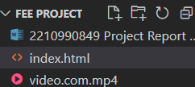

**Result**

**Currency Converter Screenshots:-**

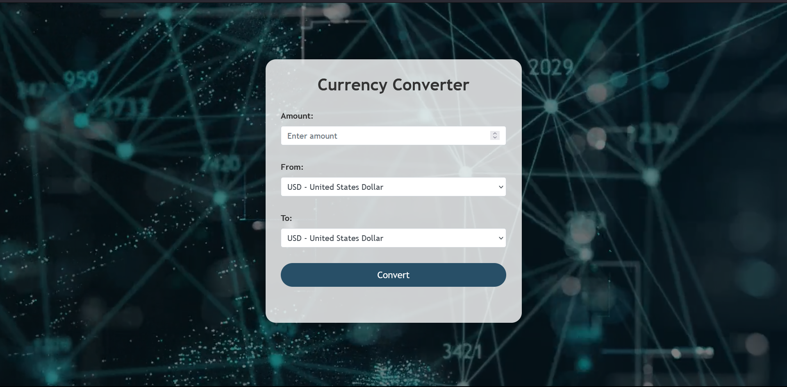

**Code:-**

HTML +BOOTSTRAP

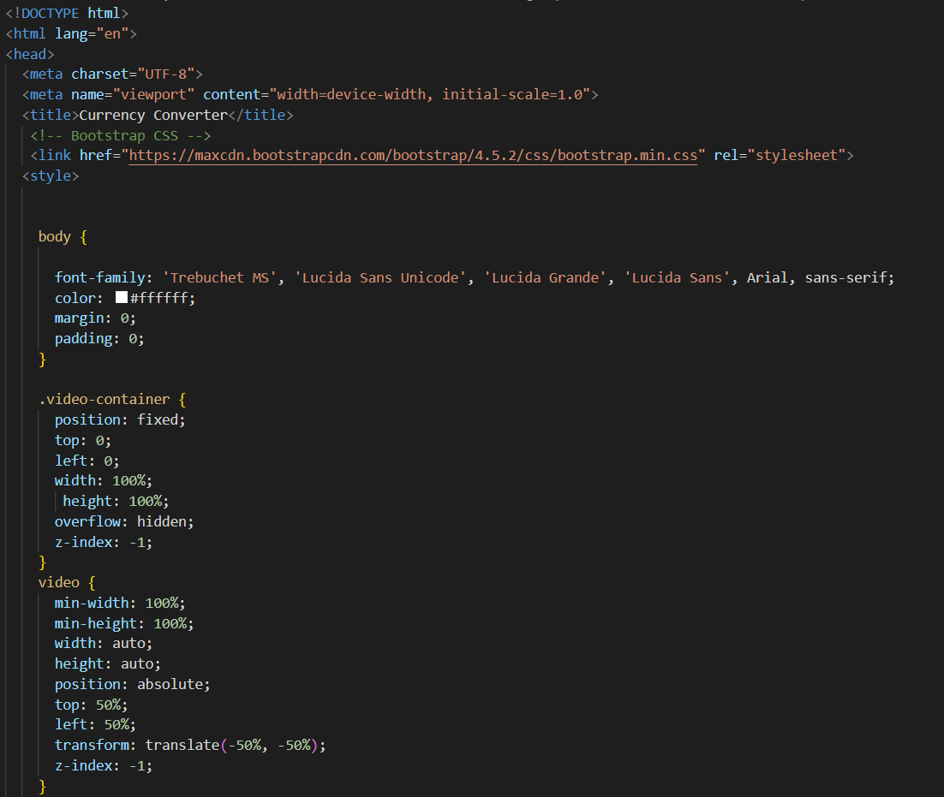

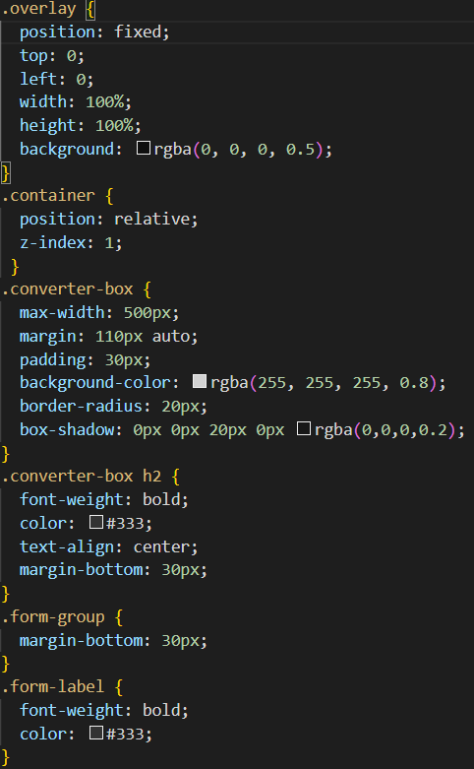

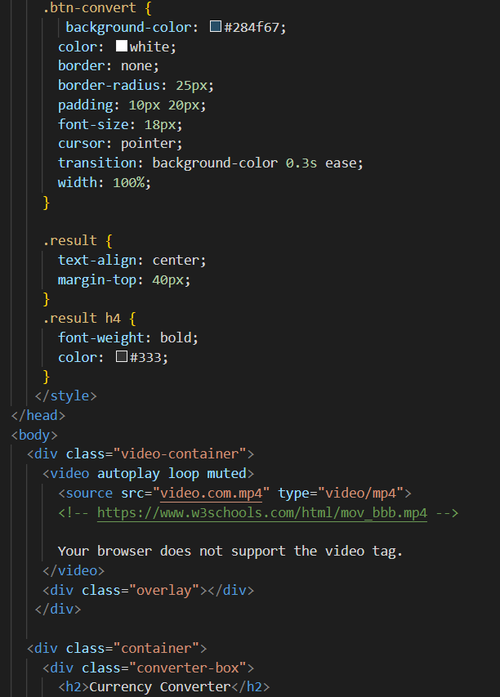

**Code:**

**JAVASCRIPT:-**

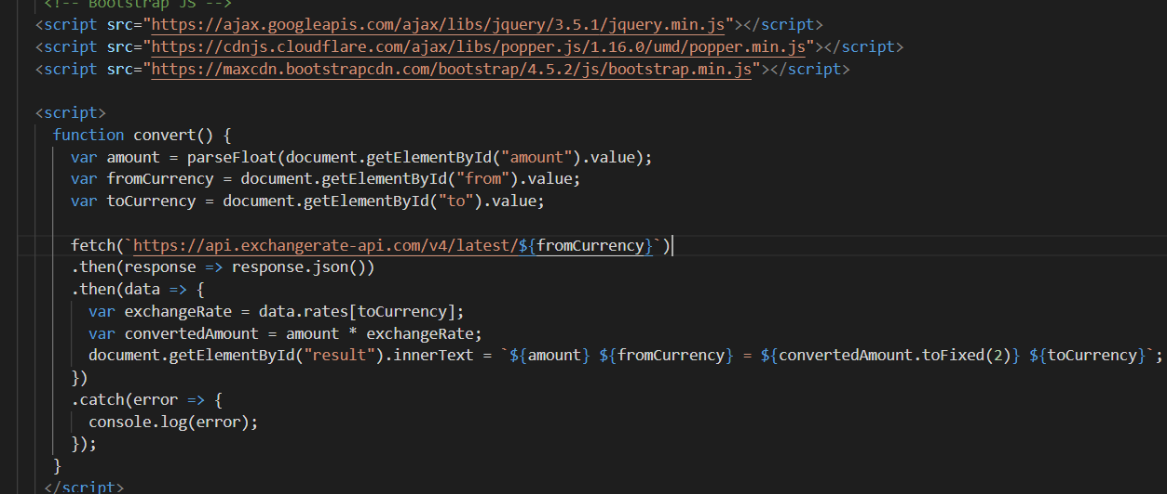

**REFERENCES**:

MDN Document

W3 School